Driving Route from National Theatre
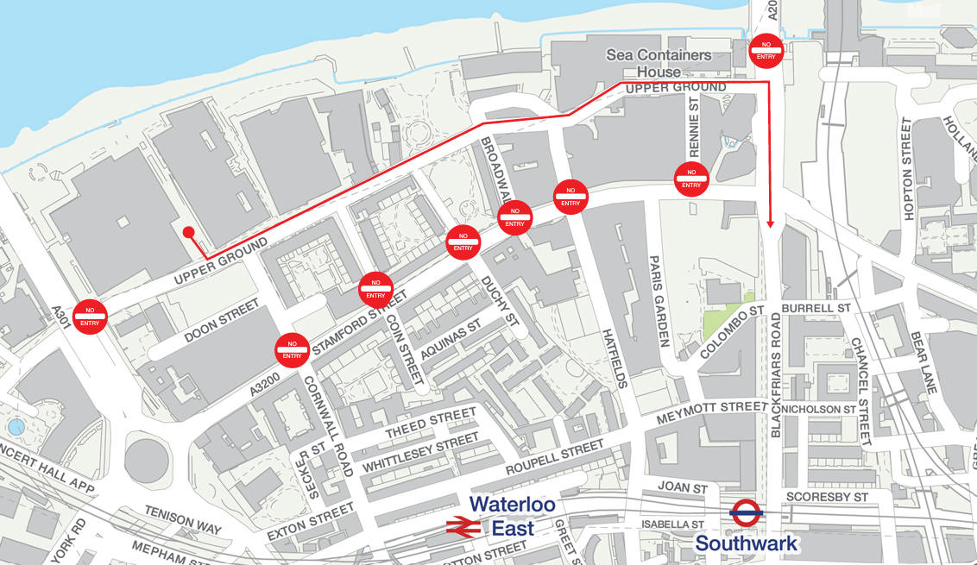
From 2pm on Tuesday 31st December there will be road closures in place to help assist with the safety and security of the Mayor of London’s New Year’s Eve Celebrations. To leave the area you must turn left out of the car park onto Upper Ground and continue to the junction of Upper Ground/Blackfriars Road, then turn right onto Blackfriars Road.

