Walking Route from National Theatre
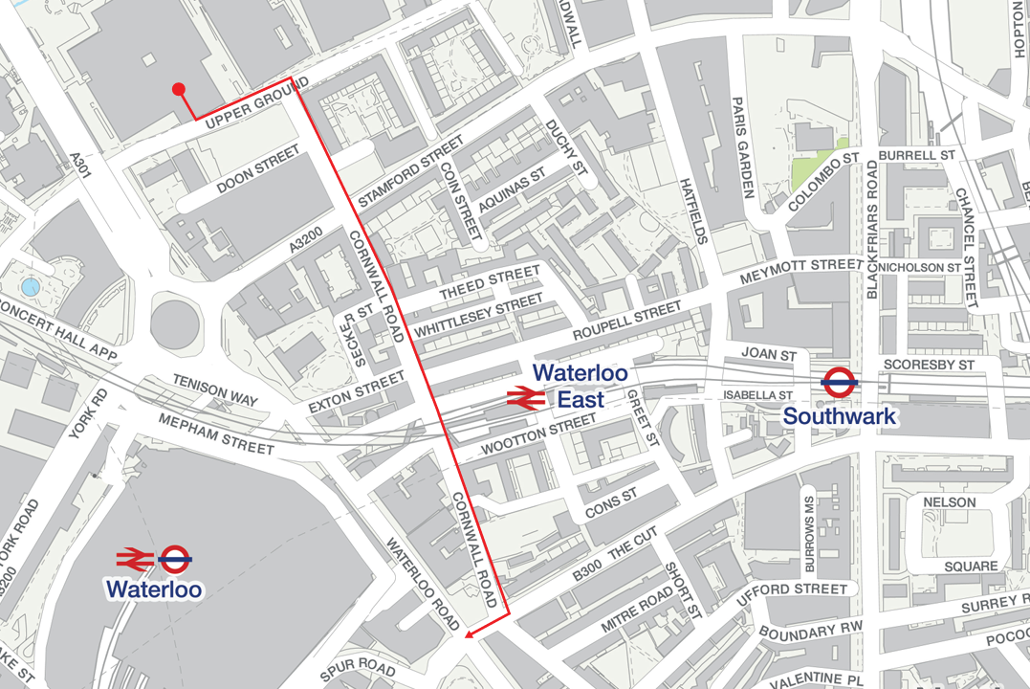
From 5pm on Tuesday 31st December there will be pedestrian restrictions in place to help assist with the safety and security of the Mayor of London’s New Year’s Eve Celebrations. To leave the area you must walk via Upper Ground, then right onto Cornwall Road straight down to The Cut. Once on The Cut you will be able to access Waterloo Sation via Waterloo Road for underground services or Spur Road for Network Rail services.

